|  |  |  |
| --- | --- | --- |
| **NO** | **URAIAN** | **HARGA** |
| 1 | |  | | --- | | ${judul_lampiran} | | **Rp. ${nilai_sp_lampiran}** |
|  | **JUMLAH** | **Rp. ${nilai_sp_lampiran}** |
|  | **PPN 11%** | **Rp. ${ppn_aja}** |
|  | **TOTAL HARGA** | **Rp. ${nilai_sp_ppn_lampiran}** |

Lampiran Risalah Rapat

${judul_lampiran}

Dibuat Oleh: Diketahui Oleh:

Off 1 Quality Of Sales & Revenue Assurance Manager Performance, Risk & QoS

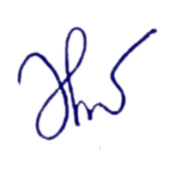

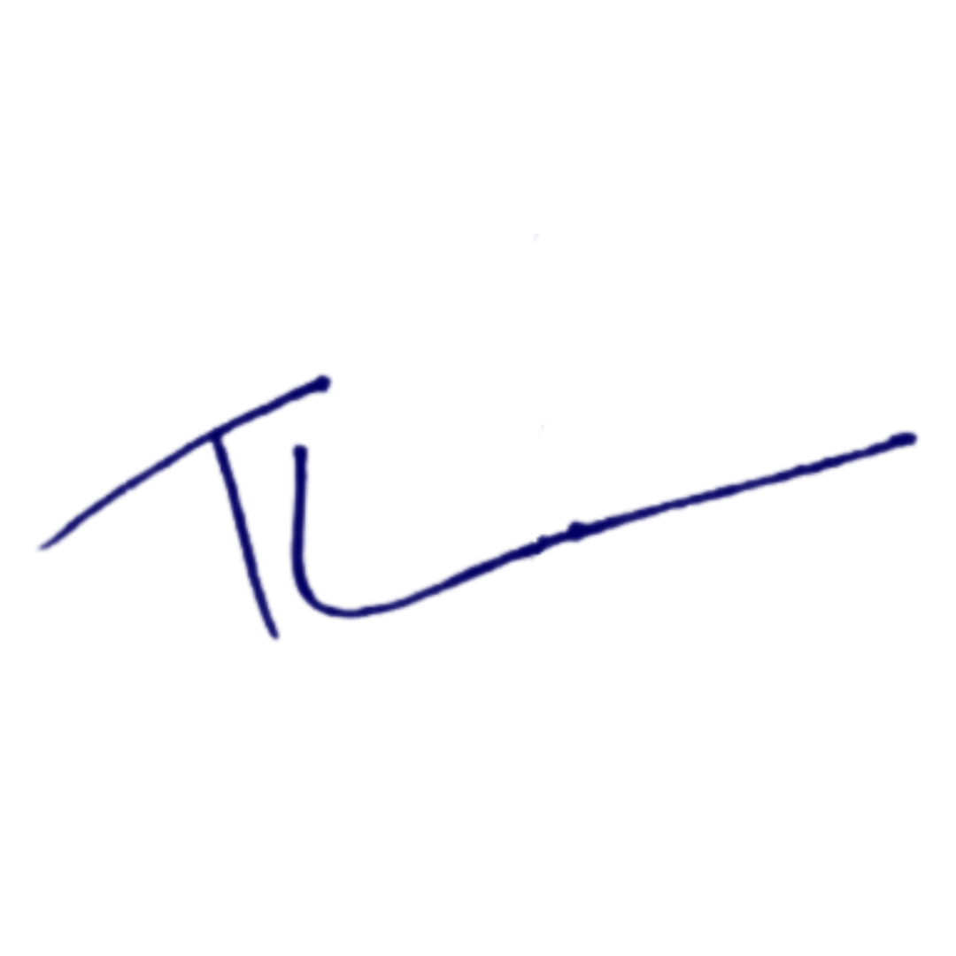

Theo Brian Ananto Siti Dahlia

NIK : 930026 NIK : 830014